

**1) Problem Definition 3**

i) Introduction 3

Customer Expectation: 4

ii) Implement Environment 4

**2) Wireframe** 5

Home 5

Category 6

Product 7

Shopping cart 7

-Add to cart 7

-Cart 9

Contact us 10

Login 11

Compare 12

-Add to compare 12

-Compare cart 13

**3) UI/UX 14**

a) Home 14

b) Category 15

c) Product 16

d) Shopping cart 17

Check out 18

e) Contact us 19

About us 20

Compare 21

Login 22

**4) Summary 22**

# **Problem Definition**

## **Introduction**

La Imperial is into selling Appliances. Company has been selling these products for last 20 years. They have a wide range of Appliances. The company advertises by distributing the pamphlets, advertising on television and so on. Due to rapid development in internet field, the company decides to launch a website where people will get all the information about the various products available with them easily

La Imperial appliances e-commerce website is provide various electronic and household appliances, such as air conditioners, washing machines, refrigerators, speakers, and many other electronic devices and products to cater to the needs of consumers looking to upgrade, replace, or shop for electronic appliances for their homes or businesses. Here is some important information you can find on an electronic home appliances e-commerce website:

Products and Categories: The website typically offers a list of products and product categories to help users easily search and browse through the types of electronic household appliances they are interested in.

Product Descriptions: Each product usually comes with a detailed description of its features, technical specifications, and images to help customers understand more about the product.

Pricing and Promotions: Product prices, as well as any special promotions, discounts, or offers, are often prominently displayed.

Contact and Customer Support: Contact information, including addresses, phone numbers, emails, and other customer support channels, is offered to assist with any inquiries or assistance during the shopping process.

News and Articles: Some websites provide information about new trends, technologies, product usage guides, and news related to the field of electronic home appliances.

### Customer Expectation:

1. Home Page should contain logo of the site with proper sections and details of Appliances with suitable images.
2. The site should display a menu which will contain the options for brief introduction about the various appliances available, location of the shop and any other information if required.
3. The information should be categorized according to the brand names of the products like if a User wants to see only “HAIER” products or any other companies products then he/she can click on a Link/button/menu etc and can see only that Brand products.
4. Another category option for different appliances, like ‘Washers & Dryers’ etc. should be created and accordingly the products should be listed.
5. When a user selects any particular brand, a list of products for that brand will be displayed
6. A brief summary of features of individual products should be displayed on the Web Page along with the product but detailed Features should be stored in Individual Word documents which can be downloaded or viewed by the User who wishes to see the same.
7. The user should also be able to compare the various products of different as well as similar brands.
8. There should be a “Contact Us” page which will have the Address of the Company which is as follows and the mail address which when clicked will invoke the local mail client from where they can send an email. Address of the Company should be displayed using GeoLocation API (eg. GoogleMaps).

## **Implement Environment**

* Notepad/HTML editor
* Figma/Adobe Illustrator
* Methodology: scrum
* Google Chrome 62.0.3202.94

# **Wireframe**

## **Home**

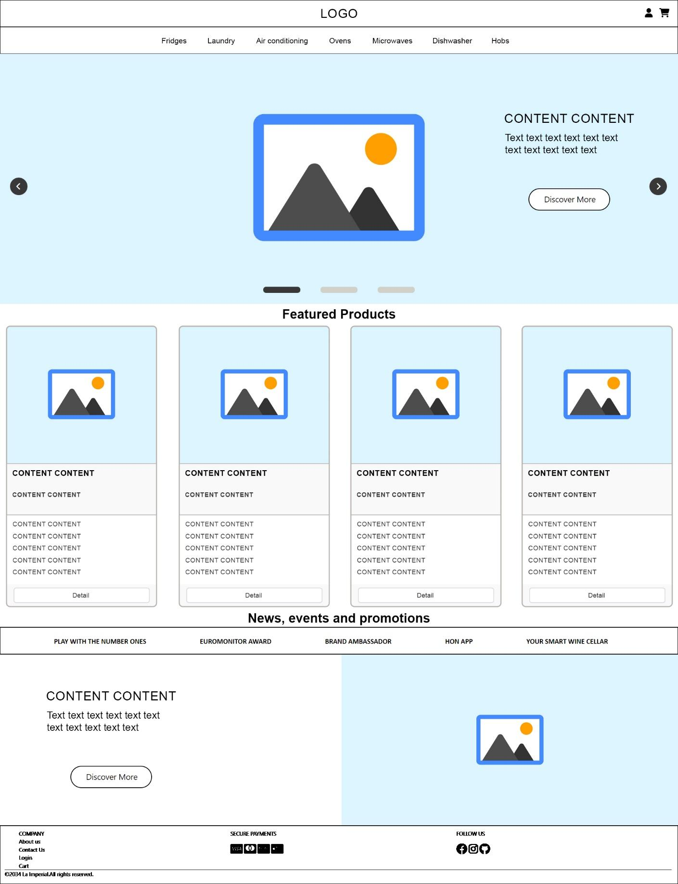

## **Category**

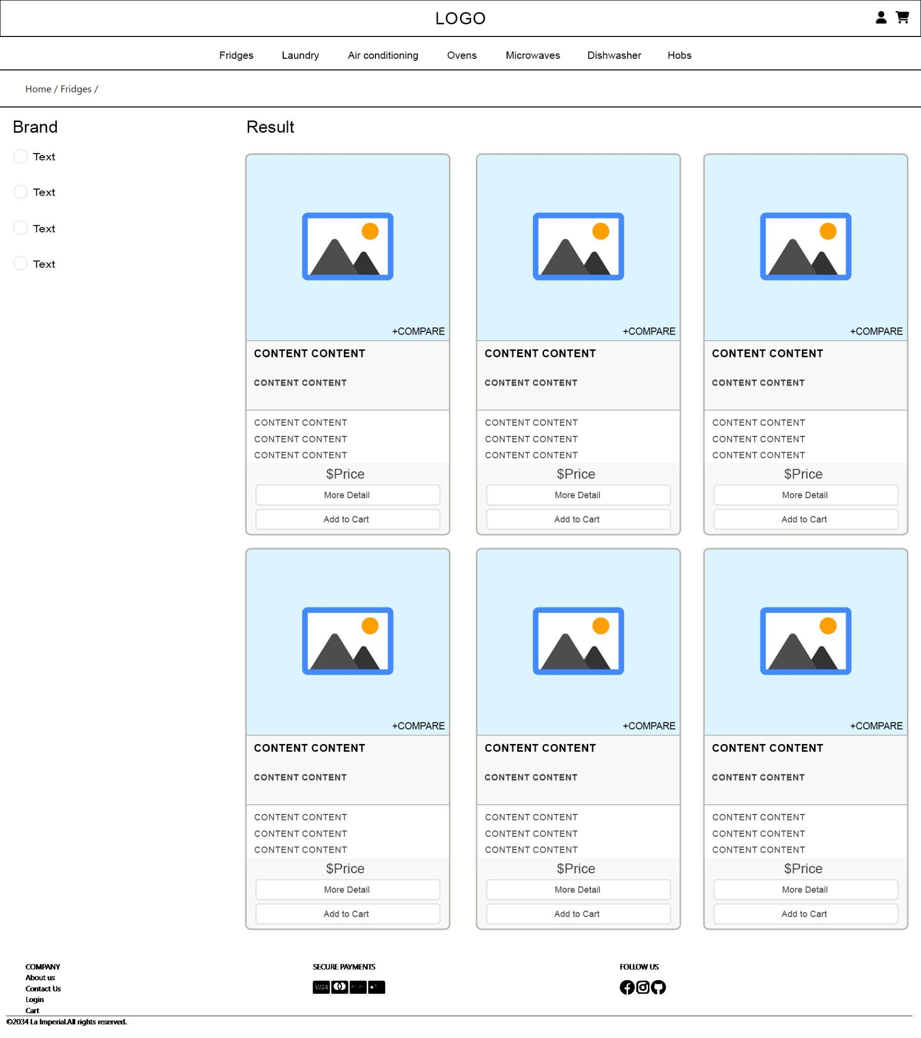

## **Product**

## **Shopping cart**

### **-Add to cart**

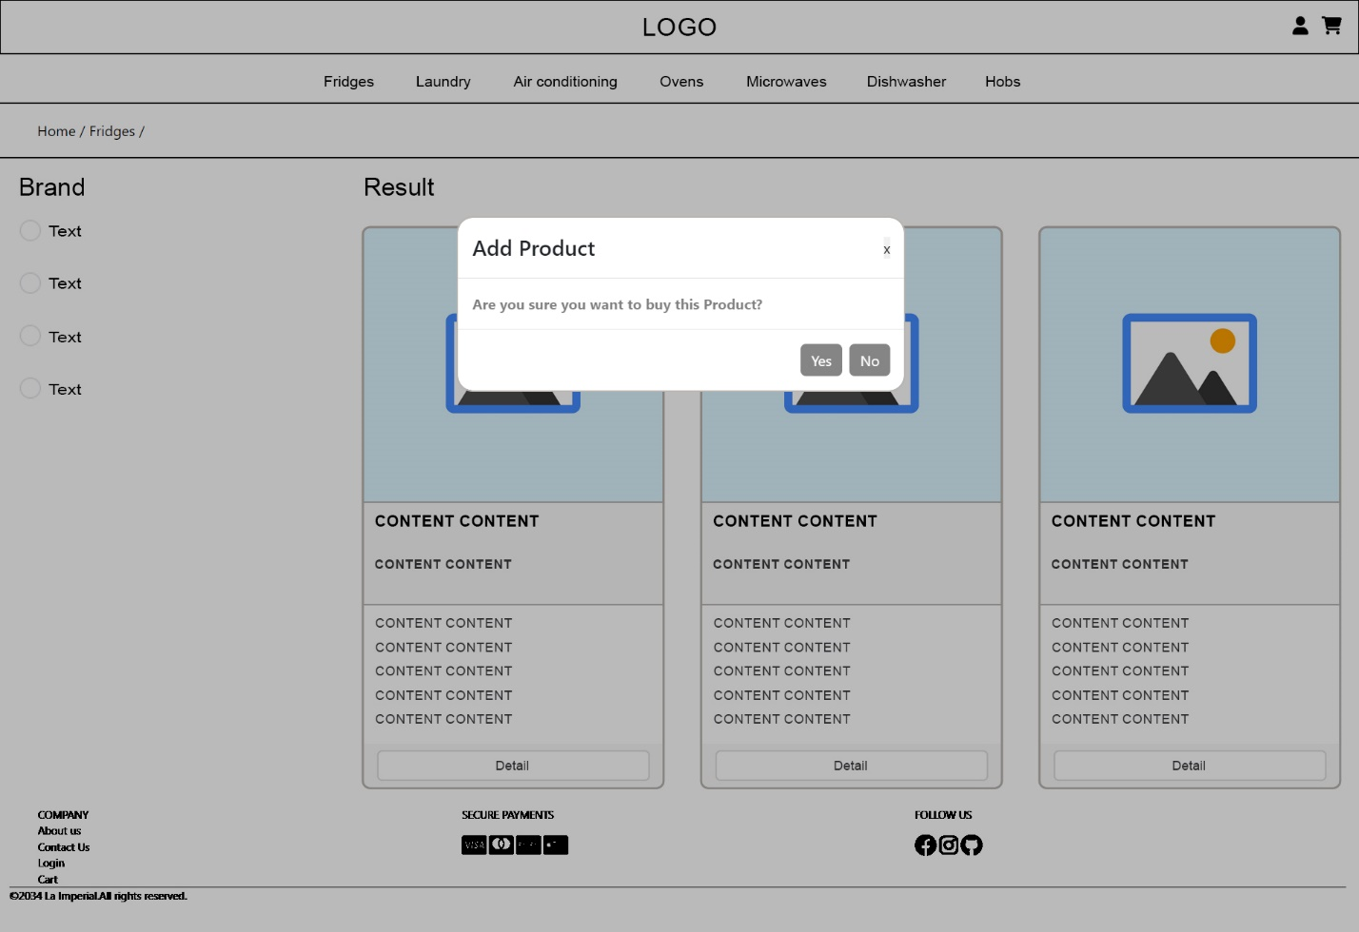

### **-Cart**

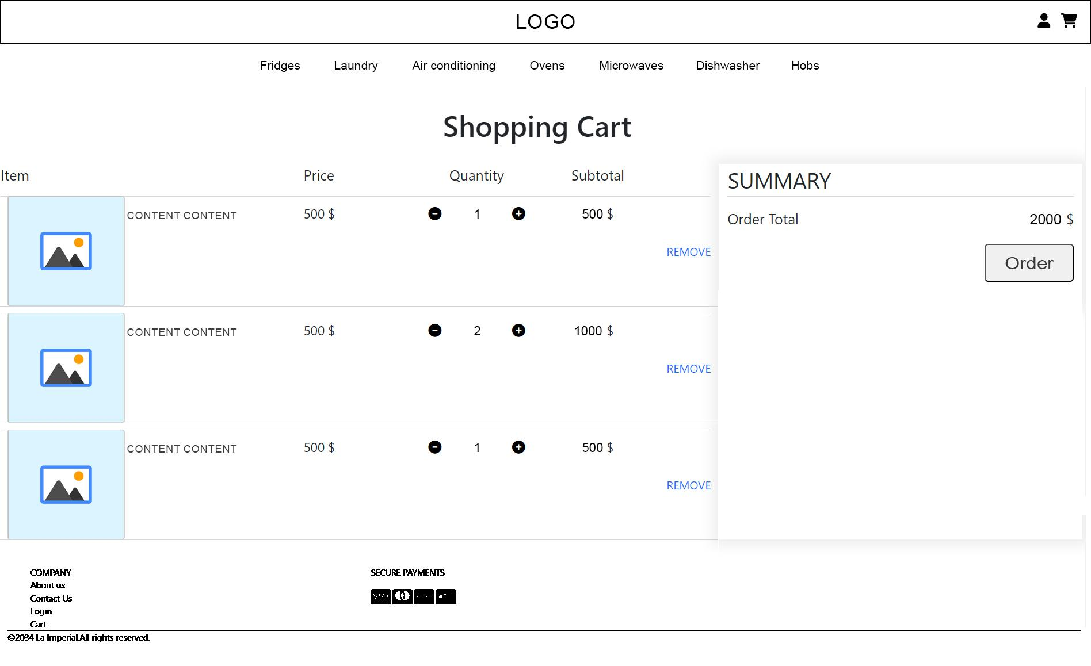

## **Contact us**

## **Login**

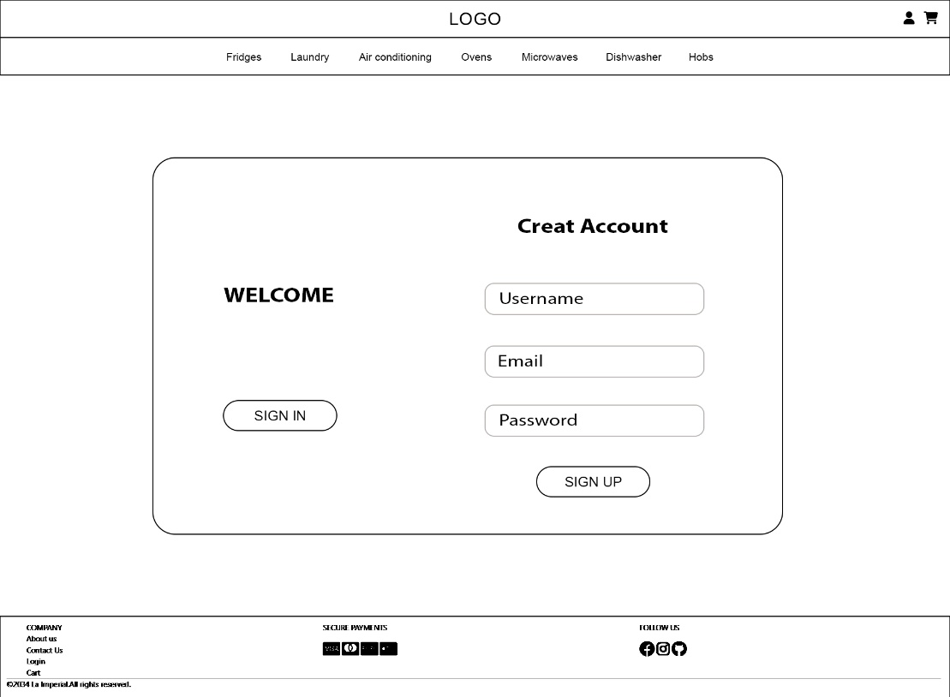

## **Compare**

### **-Add to compare**

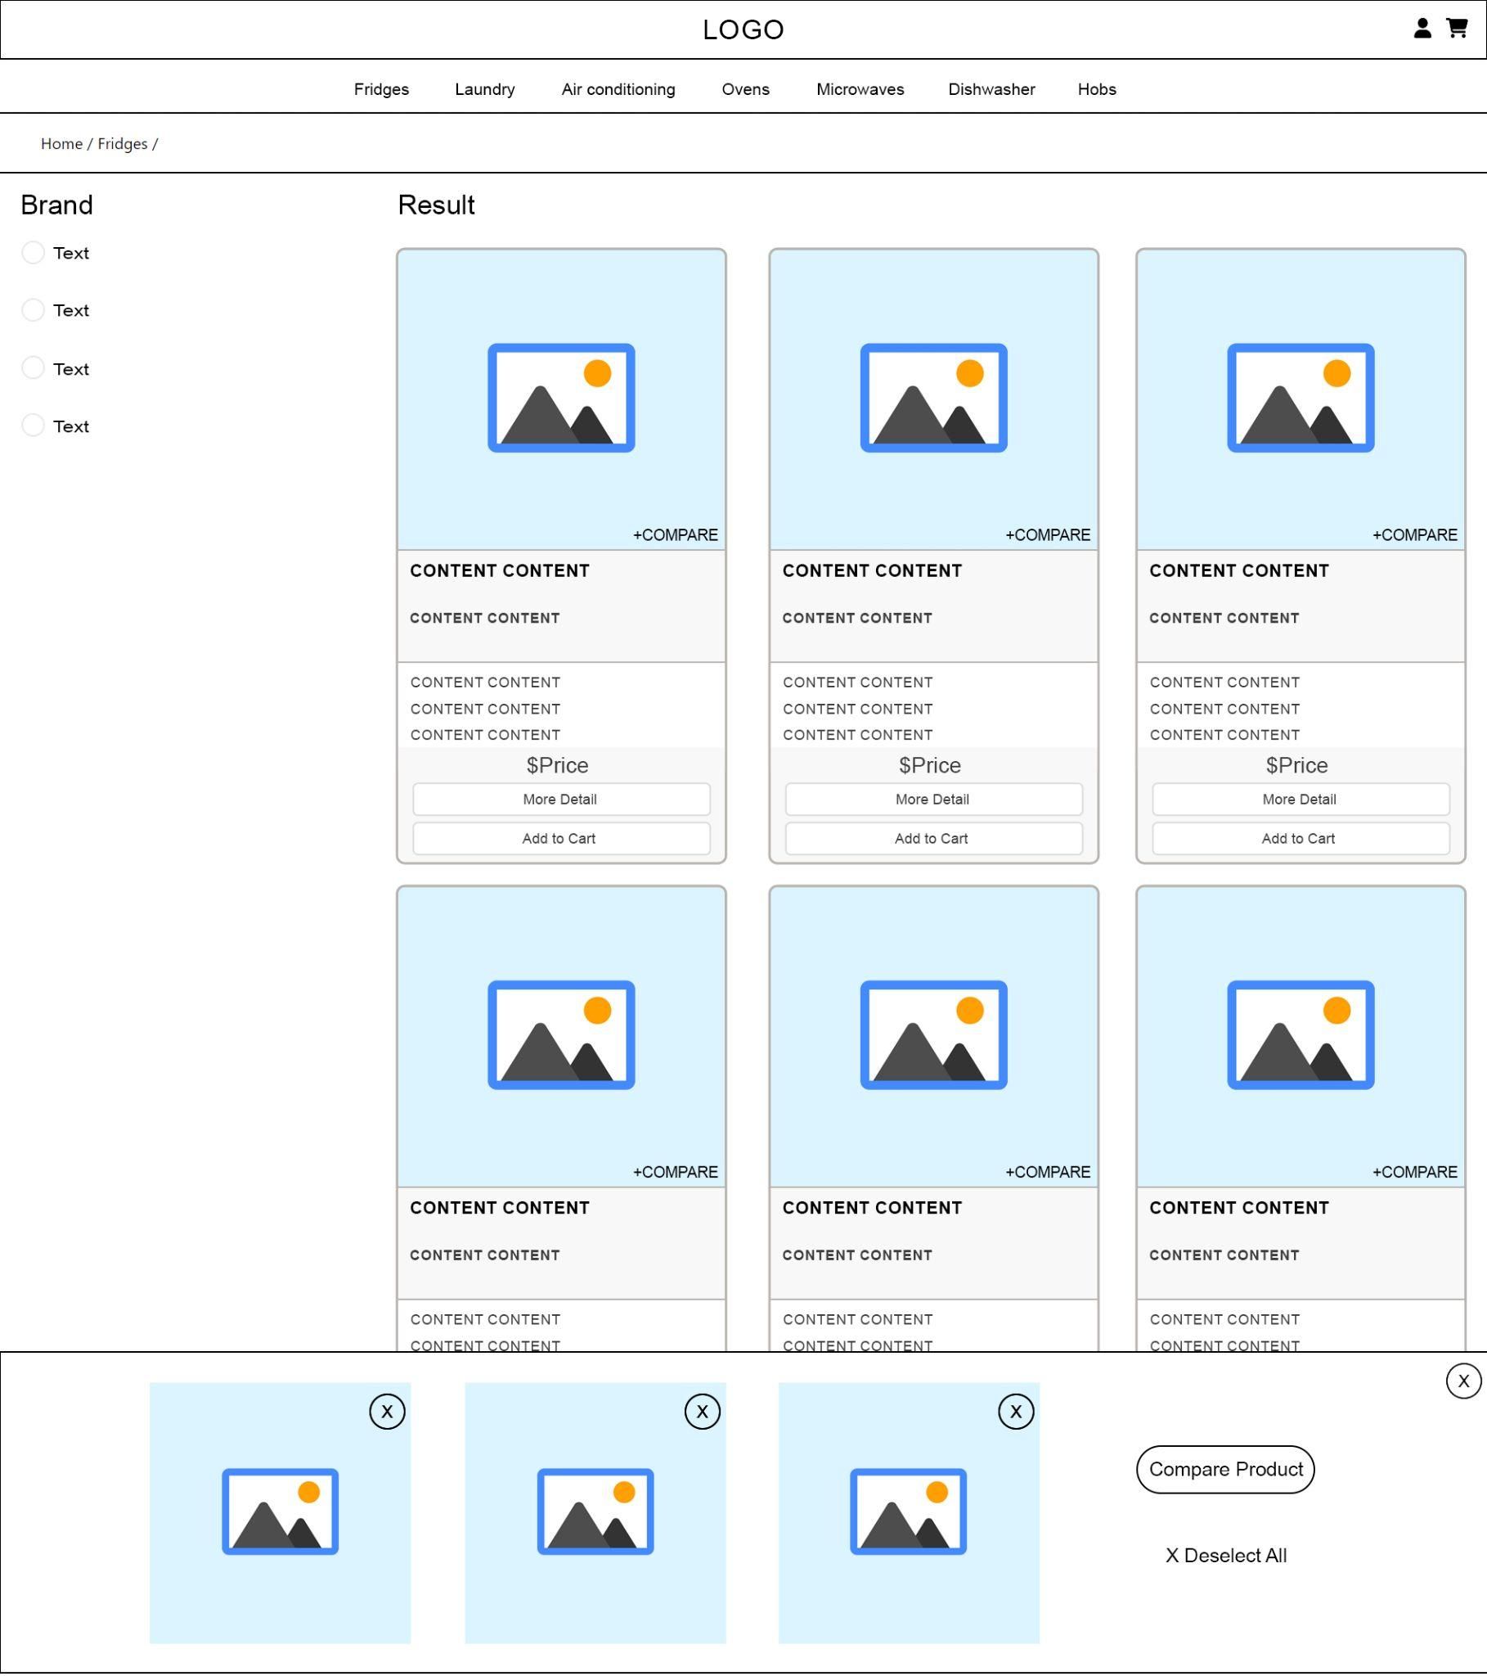

### **-Compare cart**

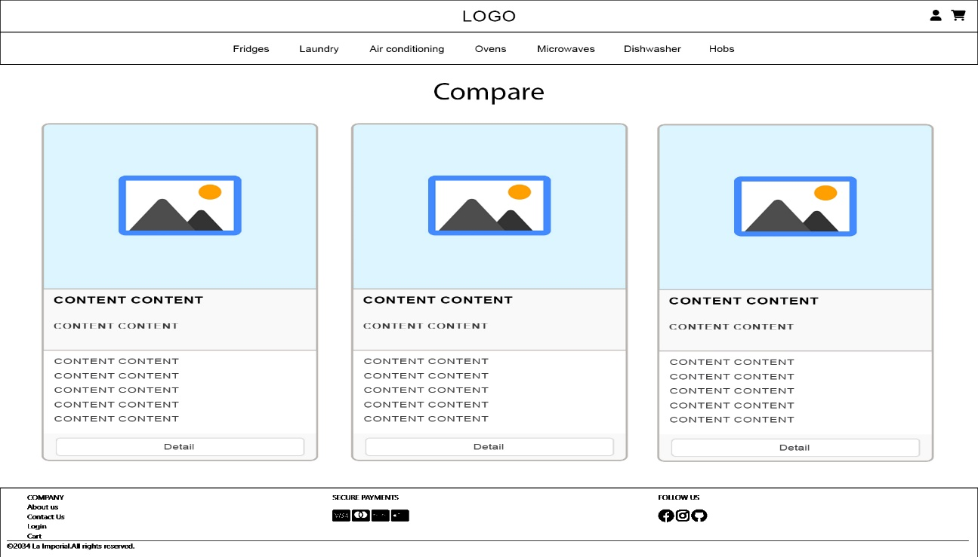

# **UI/UX**

## **Home**

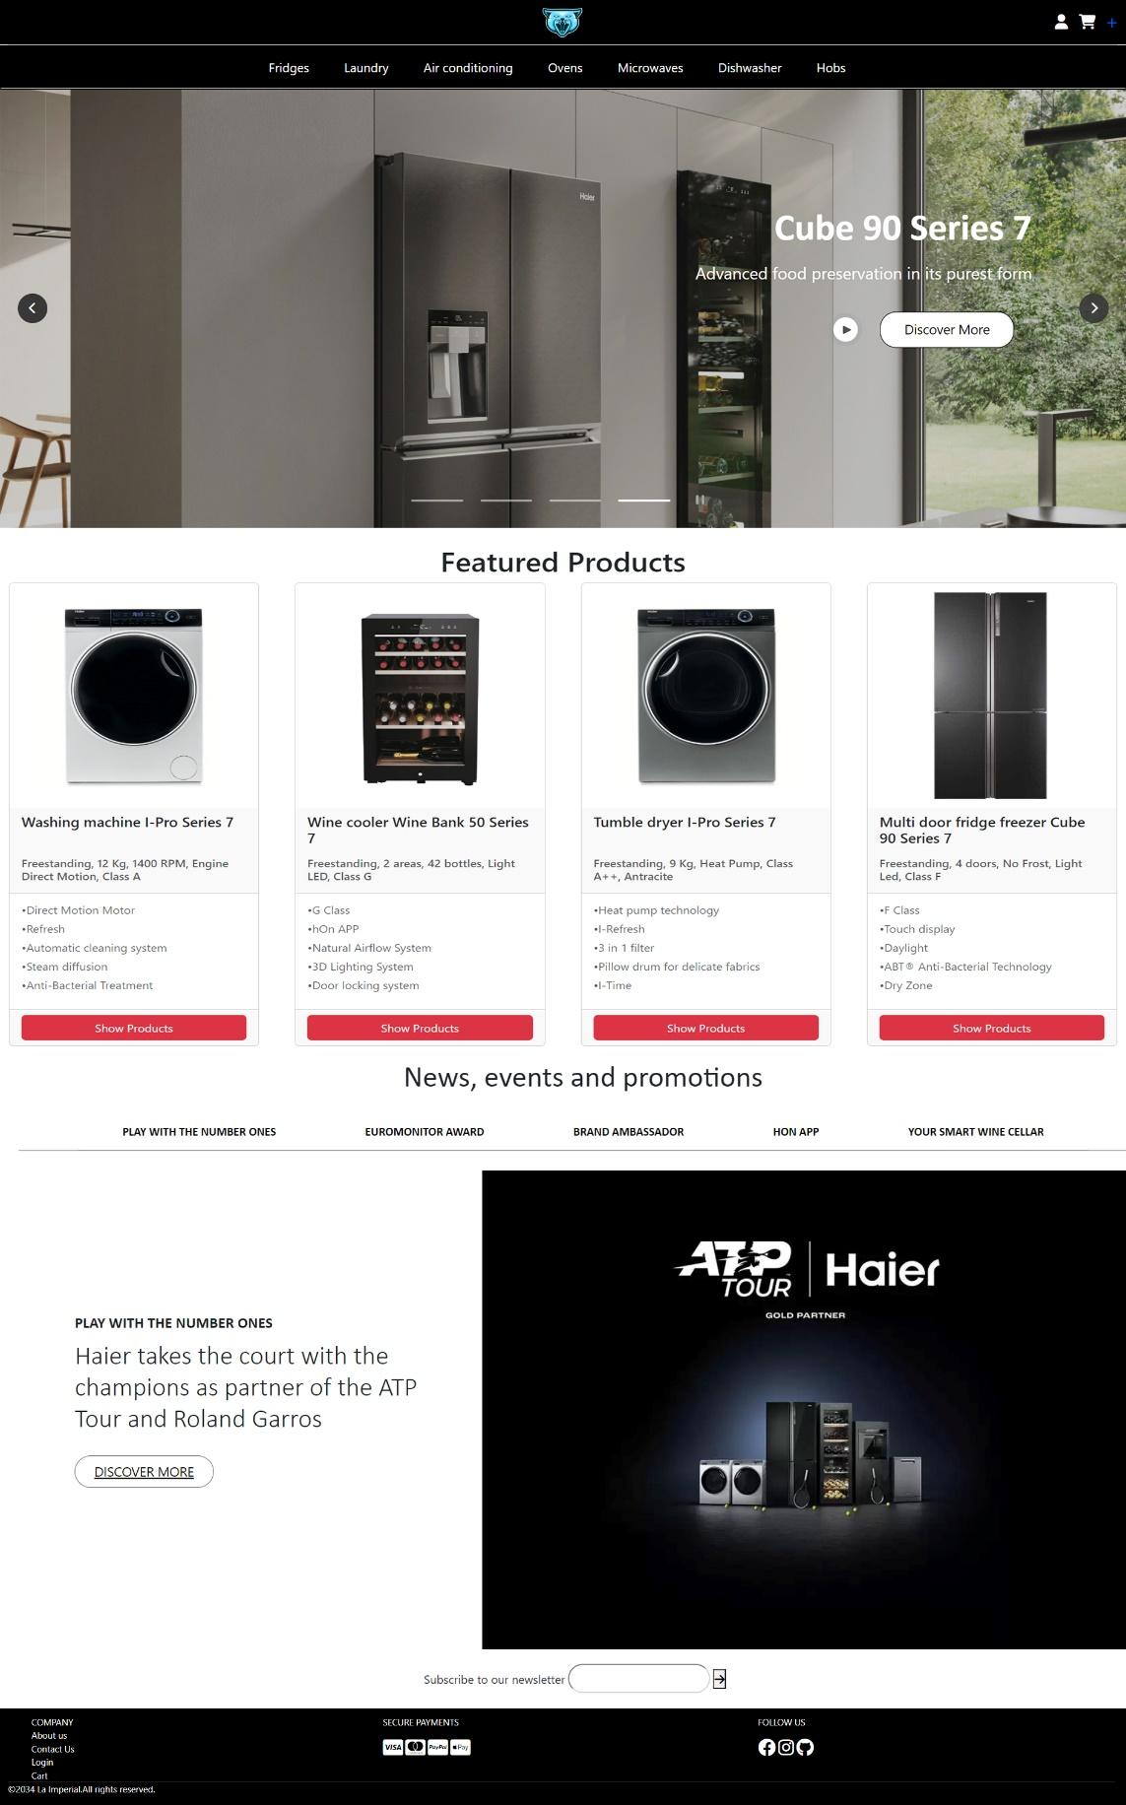

## **Category**

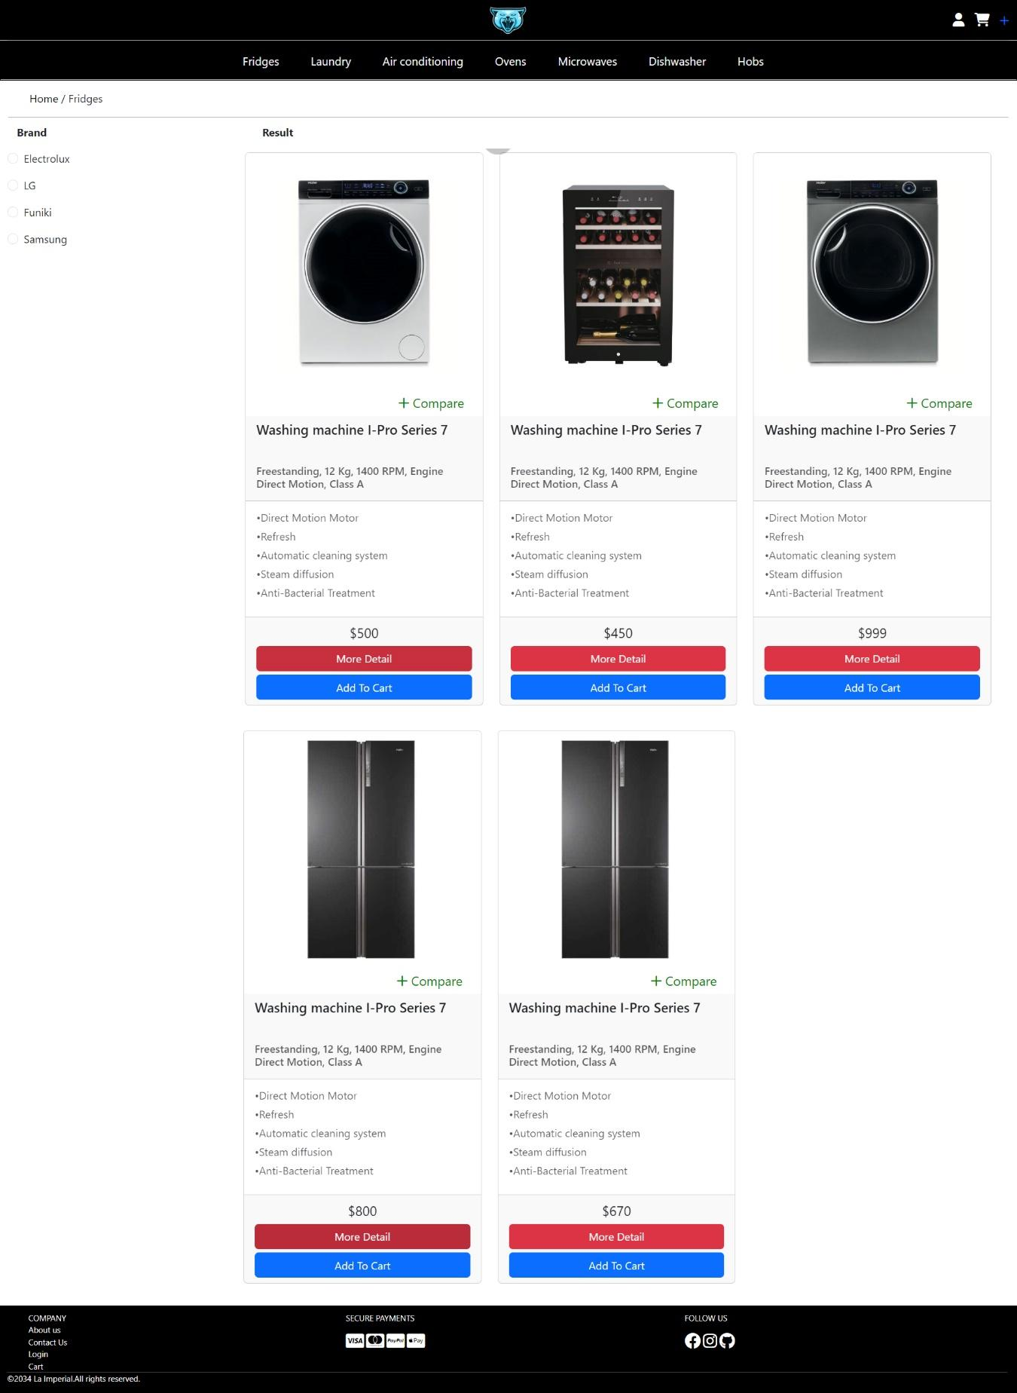

## **Product**

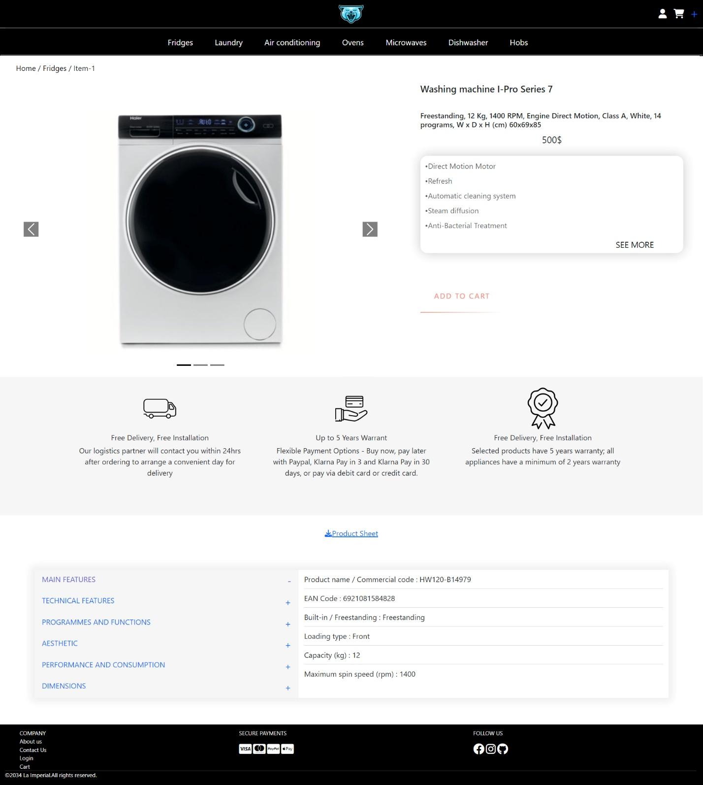

## **Shopping cart**

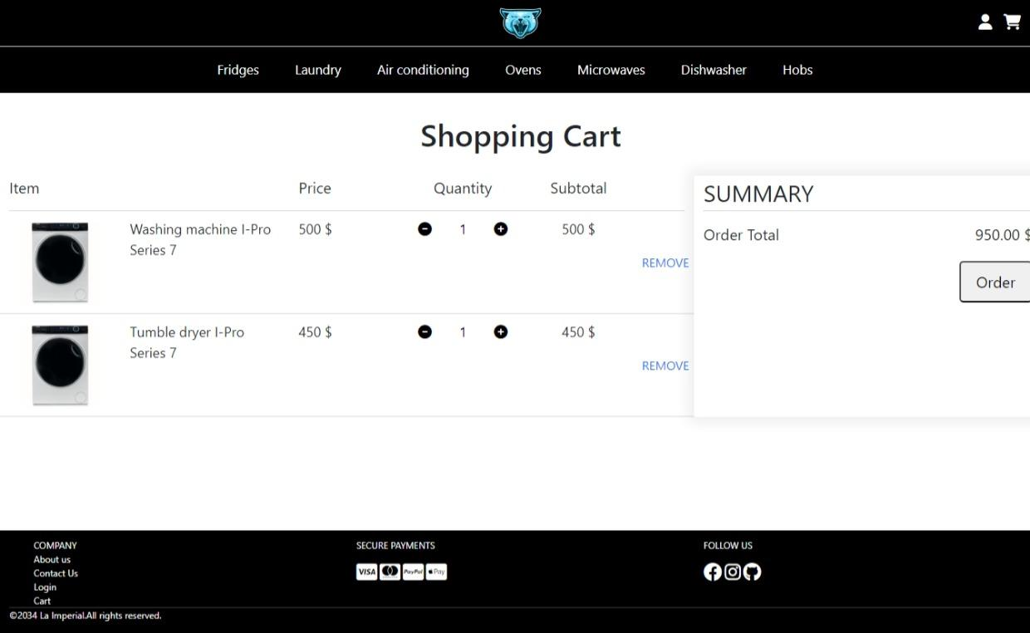

### **Check out**

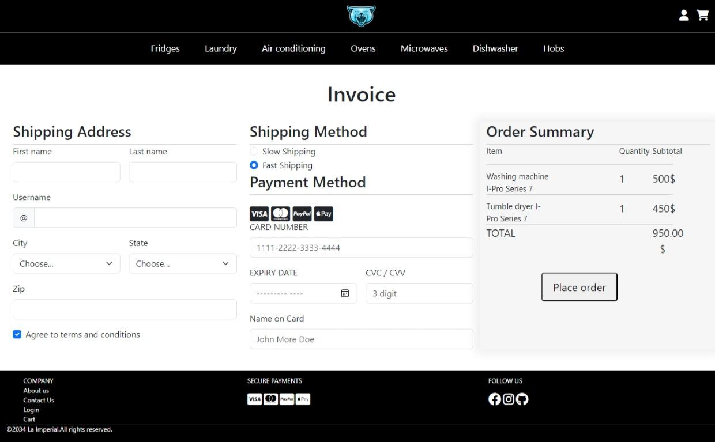

## **Contact us**

## About us

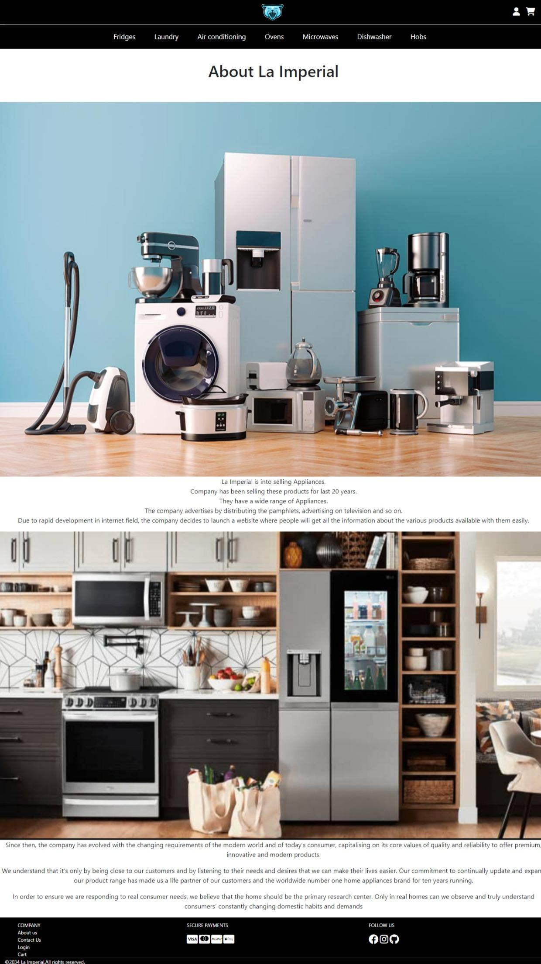

## Compare

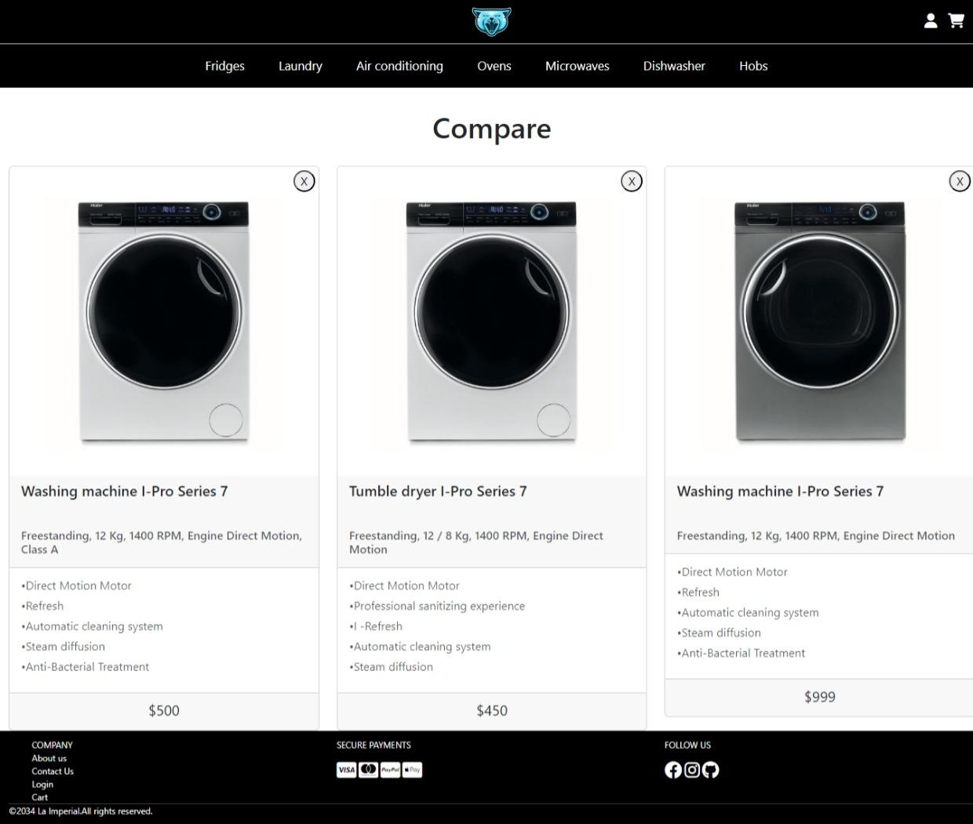

## Login

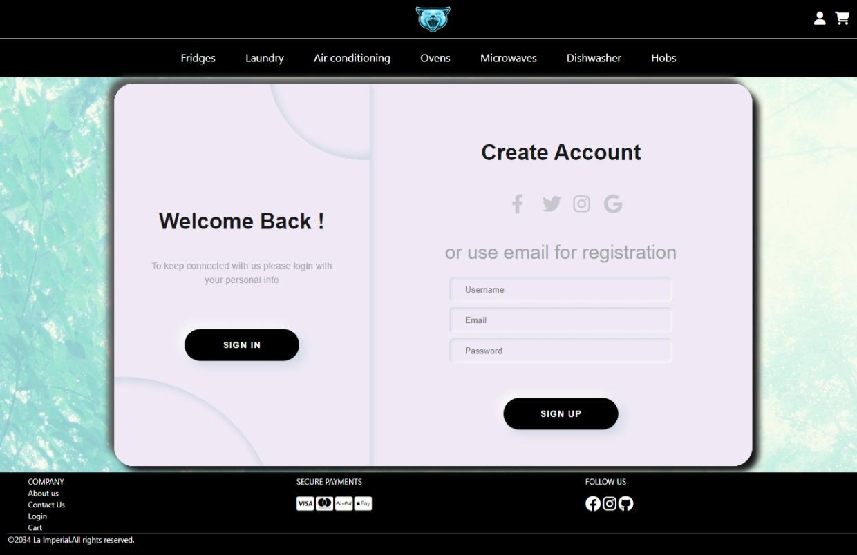

# **Summary**

# 

The (x) means that person took part in the individual work

For instance : Chu Tuan Linh did the Homepage and Header ,...

|  |  | Chu Tuan Linh | Tran Ngoc Minh | Pham Dang Tung | Nguyen Duc Quang | Luu Quang Thanh |
| --- | --- | --- | --- | --- | --- | --- |
|  | Homepage | x | x | x | x | x |
|  | Header | x |  |  |  |  |
|  | Find resources: images and information | x | x | x | x | x |
|  | Logo design |  | x |  |  |  |
|  | Login | x |  |  |  | x |
|  | Category | x |  |  | x |  |
|  | Product | x |  |  |  | x |
|  | Shopping cart | x |  | x |  |  |
|  | Contact us | x | x |  |  |  |
|  | Footer | x | x |  |  |  |
| 11. | Compare | x | x |  |  |  |
| 12. | About us |  | x |  |  |  |